

Week 5 – Revision and different classification systems

Task 1 – Scientific Name
- Write a sentence explaining what the scientific name of a species is.

- How are animals classified?

- What does MR NEGREWW stand for?

- Explain the difference between living and non-living organisms.

- Define the following words:
  - Vertebrate
  - Invertebrate
  - Exoskeleton
  - Classification
  - Features
  - Plant Cell
  - Animal Cell
  - Multicellular
  - Unicellular
  - Organism
  - Linnaean taxomony
  - Binomial naming system
  - Endoskeleton
  - Autograph
  - Key

- Give an example of how plants move by themselves.

- Explain why it is important that scientists across the world use the same classification system?

- Identify the 5 classes of vertebrates and 2 examples for each:
Class of vertebrate | Examples

- Identify if the following animal phyla below are vertebrates or invertebrates, use an example to justify your reasoning.
Animal Phyla | Vertebrate or invertebrate | Example to explain reasoning
Poriferans
Cnidarians
Echinoderms
Annelids
Namatodes
Platyhelminths
Molluscs
Arthropods
Chordates

There are 8 different classes of chordates. Identify the features of each class of chrodates.
Class of chrodates | Features of class | 2 examples of species in class

Chrodates without backbones

Agnatha (part of the fish family)

Chondrichthyes (part of the fish family)

Osteichthyes (part of the fish family)

Amphibians

Reptiles

Aves

Mammals

Task 2 – Classification keys
Create a tabular classification key for the following animals from the Madagascar movies.
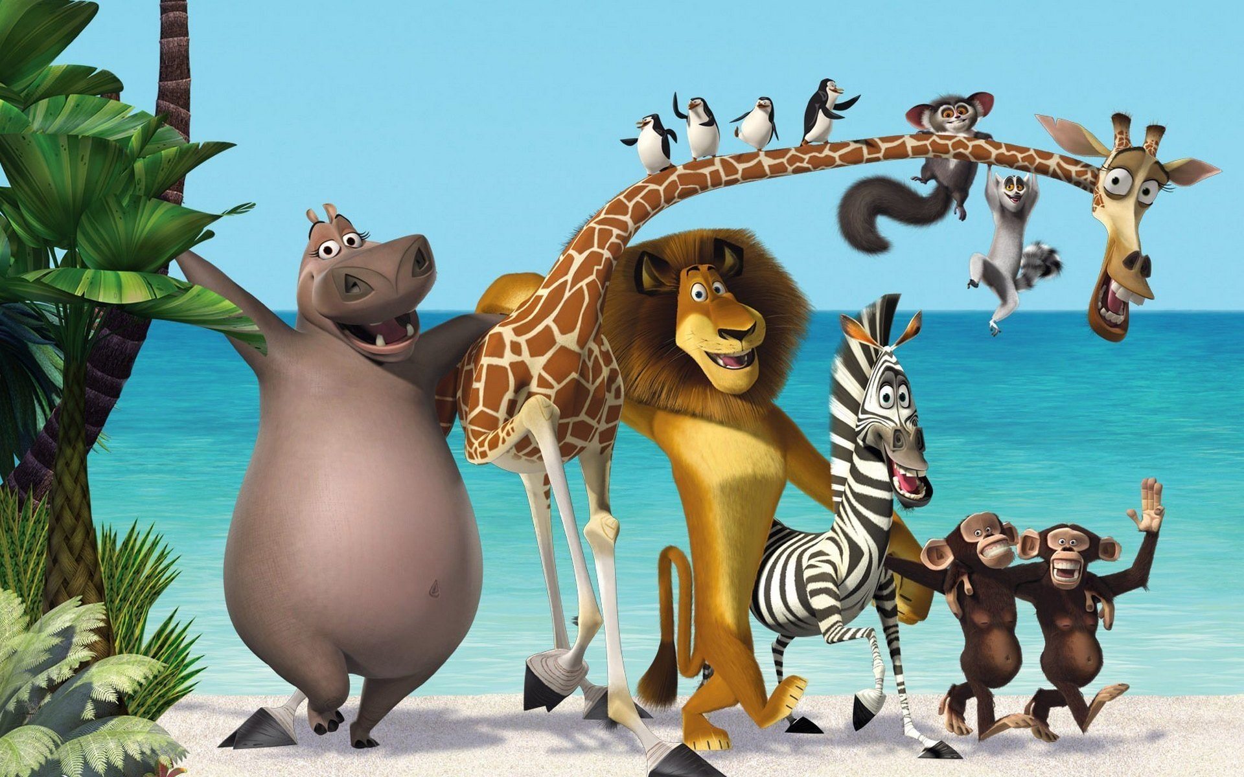

2. Create a branching classification key for the image below.



3. Create a classification key for the Disney animals. (you can make either branching or tabular).
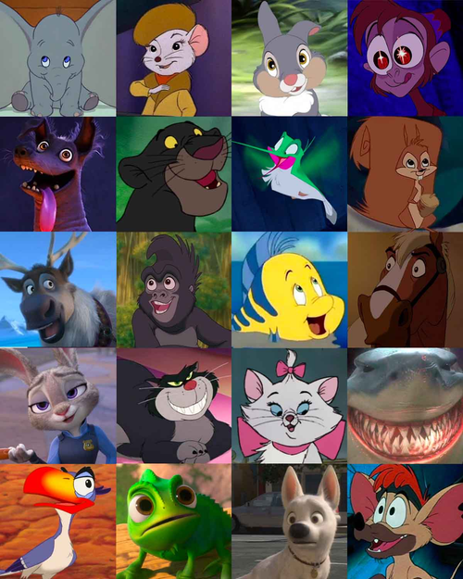

Task 3 - Aboriginal and Torres Strait Islander Peoples Classification System

Research
Click on the link below to read about the local species the Noongar people use out in Forrestdale.
https://www.perthnrm.com/wp-content/uploads/2016/09/Forrestdale-Lake-Traditional-Ecological-Database-WEB.pdf

- Fill in the table below with the Noongar words for the following plants and animals.
Common Name | Noongar name | Scientific Name | Photo
WA Christmas Tree
Tiger Snake
Western Bush Wallaby
Quenda
Woylie
Bobtail
Frog
Zamia pods
Bull Banksia
Paperbark
Orchids

- Go through the document above and list 10 different plants and their uses.

Aboriginal names describe the aspects of a plant that make it stand out to the other plants. There was often a term given to a group of plants that shared the same features. Aboriginal and Torres Strait Islander Peoples would classify organisms into subgroups which contained more than one organism. Whilst contemporary science classification systems will break organisms down by their features till there is only one organism with those specific features.

- Click on the following link and identify some of the groups that Noongar people used to classify their plants.
https://anthropologyfromtheshed.com/project/roots-of-contention-noongar-root-foods-and-indigenous-plant-taxonomy/

List 3 different sub groups the Noongar people used to classify plants and explain the meaning of the subgroups name.

Subgroup name | Origin of name | Uses of plants in subgroup

Resources used:
https://wall.alphacoders.com/by_sub_category.php?id=195204&name=Madagascar+3%3A+Europe%27s+Most+Wanted+Wallpapers
https://en.wikipedia.org/wiki/Sing_(2016_American_film)
https://www.buzzfeed.com/pablovaldivia/disney-animals
https://anthropologyfromtheshed.com/project/roots-of-contention-noongar-root-foods-and-indigenous-plant-taxonomy/
https://www.perthnrm.com/wp-content/uploads/2016/09/Forrestdale-Lake-Traditional-Ecological-Database-WEB.pdf

